**Chapter 5: (STP)**

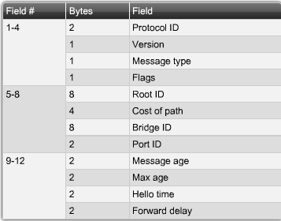

Spanning-Tree Protocol (STP):

- Prevents loops and broadcast storms (because Ethernet frames have no TTL field)

- Loops occur when there are multiple paths to the same node (redundancy) and

- Happens with both broadcast and unicast frames (for unicast, duplicates can be sent)

- Ensures one logical path by blocking redundant paths on the network

- Can use PVSTP or PVSTP+ (Per Vlan STP), Cisco proprietary

- Involves one instance of spanning tree running on each VLAN

Spanning Tree Algorithm:

- Switches running STP communicate through bridge protocol data units (BPDU)

- Each switch has its own unique bridge ID (BID) to identify it in STP

- BID is calculated based on switch priority and MAC address (lower = better)

- BID priority = priority + VLAN

- If bridge priorities are the same, then MAC address is used to elect root bridge

- Switches calculate root bridge by selecting the switch with the lowest BID

- Root bridge is the bridge used for all relative path calculations

- Determines best paths to root bridge for all nodes in the broadcast domain

- Best path = lowest path cost (also takes into account port cost as well)

- Root ports -- switch ports that are closest to the root bridge

- Designated ports -- non-root ports that are still allowed to forward traffic

- Non-designed ports -- ports disabled by STP to prevent loops from occuring

STP Convergence:

- Elect a root bridge (see above)

- Choose one root port for every non-root switch

- Elect the designated ports (all ports on root bridge are designated ports)

- On topology change, switch sends TCN out root port, and bridges respond with TCA

Port States:

- Blocking -- receives and processes BPDUs, but cannot forward traffic

- Listening -- still can only receive BPDUs, but progressing to another stage

- Learning -- port is able to learn new MAC addresses

- Forwarding -- port is active and can forward frames and receive BPDUs

- Disabled -- port is disabled and nothing can happen

- Progression -- Blocking -> Listening -> Learning -> Forwarding (Disable is manual)

IOS Commands:

- spanning-tree cost [COST] -- sets the cost for an interface in STP (in config-if)

- spanning-tree vlan [VLAN] root primary -- sets priority to make switch root bridge

- spanning-tree vlan [VLAN] root secondary -- makes switch root bridge if primary fails

- spanning-tree vlan [VLAN] priority [PRIORITY] -- sets STP priority for the switch

- spanning-tree port-priority [PRIORITY] -- sets priority for an interface (in config-if)

- no spanning-tree cost -- removes the cost for an interface (in config-if)

- show spanning-tree -- shows all STP configuration and status information

RSTP, RPSVT+